

Department of Computer Engineering

Spring 2017

CMPE 272 Project Report

Smart Helmet

By

Team – 4

Sai Ravi Tejabhishek Sreepada

Sai Krishna Jonnalagadda

Ravi Teja Tatipamula

Kshama Shalini

Under the guidance of

Prof. Rakesh Ranjan

# Abstract

Internet revolutionized our entire view with the help of IOT (Internet of things). As we all know Motor Cycle is one of the common and fastest transportation to our destination, Due to this, many casualties occur every year so we have come up with an idea where if a driver meets with an accident, the location of the driver will be sent to the emergency contacts so proper medical care will be taken which reduces the number of casualties by 3 times. Thus, Smart helmets have made their place for the existence in this revolutionizing modern era. The fatalities caused due to bike accidents have been going higher and higher every day and the invention of smart helmets had become a compelling invention.

Looking at the statistics about 70 percent of the casualties occur due to unavailable medication on time. Our project mainly focuses on reducing the number of deaths. Smart Helmet is implemented using GSM and GPS technology. The working of a Smart Helmet is also easy where we will place various sensors on the helmet which are connected to a micro controller. So when the rider crashes and hits the ground the sensors will provide this information to Microcontroller. The Microcontroller extracts GPS data using GPS model which then automatically sends an SMS to emergency contacts provided.

x



Fig – Helmet Prototype

# Acknowledgements

The authors are deeply indebted to Professor Rakesh Ranjan for his invaluable comments and assistance in the preparation of this project.

# Table of Contents

**Chapter 1. Project Overview………………………….………………………….............. 5**

**Chapter 2. Motivation……………………………………...……………………………… 7**

**Chapter 5. Working………………………………………………………………………... 7**

**Chapter 3. Block Diagram….………………………………….………………………….. 9**

**Chapter 6. Conclusion…………………………………………………………………….. 10**

**Chapter 7. Future Improvement…………………………………………………………. 11**

**Chapter 8. References………………………………………………………………………12**

# Chapter 1. Project Overview

**1.1 Introduction**

Number of fatalities caused by bike accidents is increasing every year for past 11 years. About 16 bike accidents occur every hour. From 1990 to 2008, deaths caused by bike accidents have nearly doubled. [1] Every year, thousands of people die due to delayed medical facilities. In remote areas where the population is very less, when any accident occurs, no one is there to call an ambulance on time. About 70% of the casualties occur due to delayed medication.

If we look at the statistics shown in the chart below, 28.8% of total accidents that occurred in India were based on two-wheelers. [2]

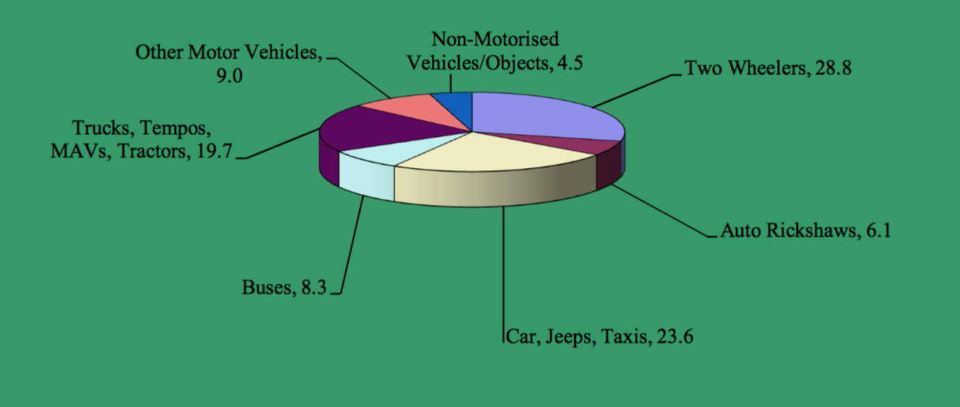

**Fig[ ]: Percentage of accidents based on type of motor involved in India in 2015[2]**

According to the report issued by Government of India, in 2015, 31.5% of people killed in road accidents were using two wheelers for their commute.[2]  If people would have been informed on time about the accident and the exact location of the accident, they would have gotten proper medical care facilities on time and their lives could have been saved. Finding a proper solution to this problem is extremely essential. By getting proper accident alerts on time and by providing medical care immediately, many people can be saved.

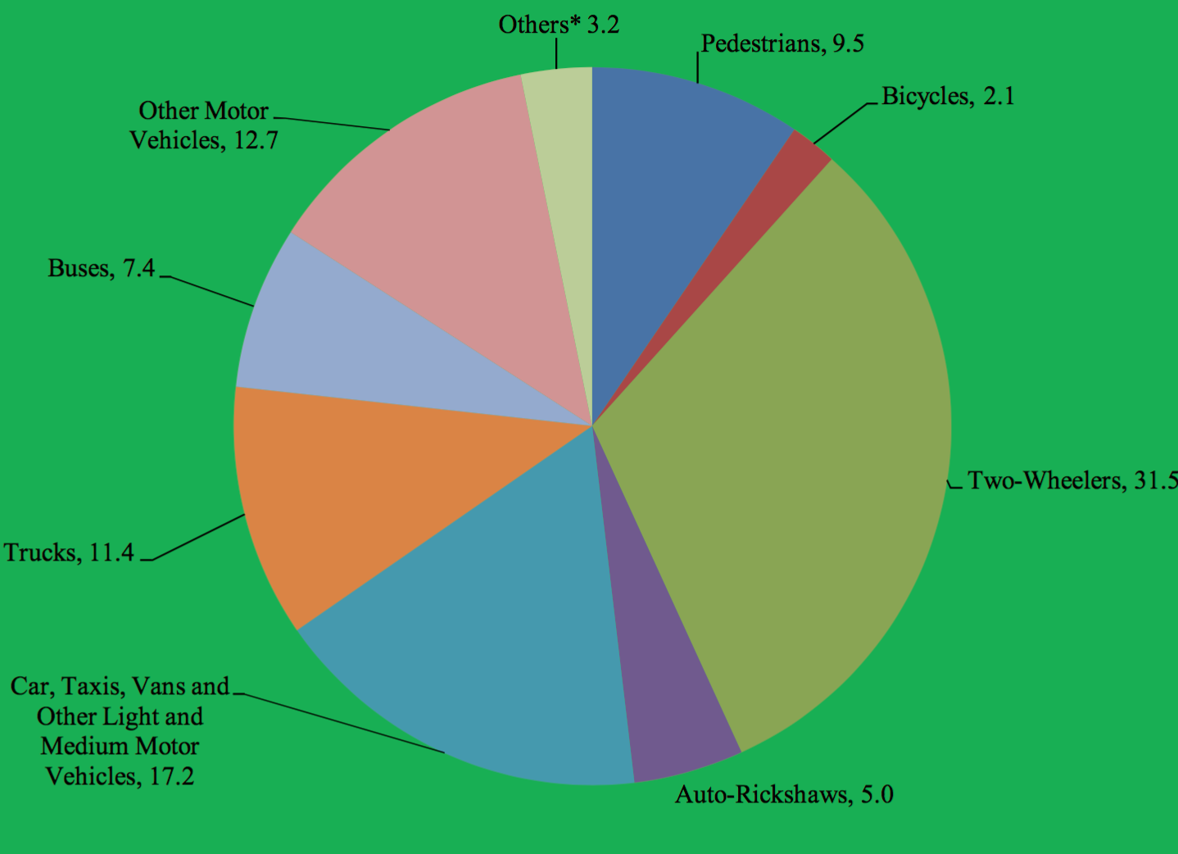

**Fig[ ]: Percentage of people killed in accidents based on road user categories in India in 2015[2]**

Smart helmets are the solution to this problem. Smart helmet is used to deliver real-time data about the location as well as time of the accident so that proper medical facilities can be provided to people on time. There are varieties of smart helmets available in the market that can serve the same purpose. However, the cost of these helmets vary from $500-$700. Average customers generally won’t be willing to pay extra $500-$700 just to get a smart helmet.

We have developed a smart helmet that is not only cost-effective, but it is also effective in finding the location of the accident along with sending message alerts to friends and family members. Cost of developing this smart helmet is very less compared to that of the ones that are available in the market. We have developed the helmet using hardware components such as Linkit One, ADXL345 accelerometer, GSM, GPS and Wifi antenna. We have used Arduino IDE platform for writing smart helmet program and uploading it to the Linkit One board.

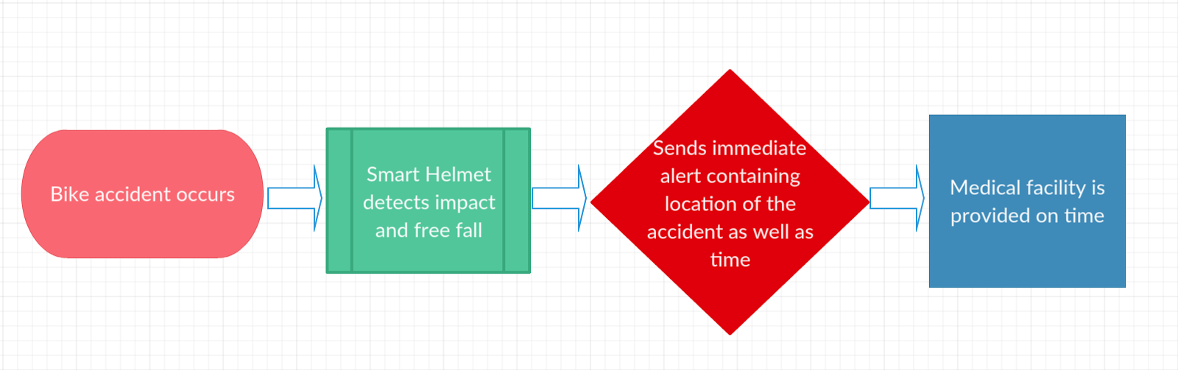

**Fig[ ]: Flow Chart of working of Smart Helmet**

# **Chapter 2. Motivation**

Our main motivation behind this project is to provide medical care for people who have met accidents without any delay. Smart helmet if the rider using this helmet met with an accident, the impact and free fall is detected by the accelerometer and sends it to the Linkit one then Linkit one retrieves the GPS co-ordinates of the user and sends a message with co-ordinates to Emergency Services and also to Family members, by doing so there will be no delay in medication and the chances of delayed medication will decrease along with number of victims by 9%

The idea of this project is to build a Smart helmet which can be afforded even by a common man, to achieve this we have carefully selected the minimum hardware required so as to prevent any unnecessary costs by providing additional features. This Helmet will be provided with basic features so that every victim who met with an accident will be provided with proper medical care.

**Production:**

This Product is cost effective so that it can accessed by a common man.

The Total cost of this product is less than **100$** which includes Linkit One, GSM,GPS,WIFI,Bluetooth antenna, ADXL345 accelerometer, BreadBoard, Push Button, SIM Card

The Cost Includes

* Linkit One-34$
* ADXL345 accelerometer-8$
* BreadBoard-4$
* Push Button-2$

**Working:**

**Smart** Helmet here detects the free fall, gravity of the impact and detects the coordinates of the impact and send the information of the location to either pre fed number or to the paramedics emergency.

The functioning of the project requires the following equipment.

**1) Linkit ONE** : Linkit One is the micro controller which is the motherboard of the functionality. Arduino Linkit One is the amazing platforms to support this project.

Linkit One is the working and development board made by Mediatek and seeed studio.The board is pin compatible and consists of following sensors.

* **GSM/GPRS radio for cellular connectivity** : GSM and GPRS is used to send text messages during emergency or make voice calls. GPRS can also be used to make most of Internet.
* **Wi-Fi radio** : WiFi is used to send wireless transmissions. Here, to send a signal or trigger the functionality or to interrupt the signal transmission.
* **GPS radio** : Used to record the GPS coordinates.
* **Bluetooth radio 2.1 / 4.0** : Used for making handsfree voice calls.
* **SD/Sim card slot :** This slot is used either for SD card or for sim card.SD card for storage and Sim card to make use of cellular network.

**2) ADXL345 accelerometer :** Accelerometer as the name suggests is a device which measures acceleration. Accelerometers have got many applications in many industries. It is used to detect the free fall. Threshold of the impact can also be set. Accelerometer can also help us plot of it’s trajectory. All the coordinates with real time can be recorded and sketched. The circuit connections can be shown as follows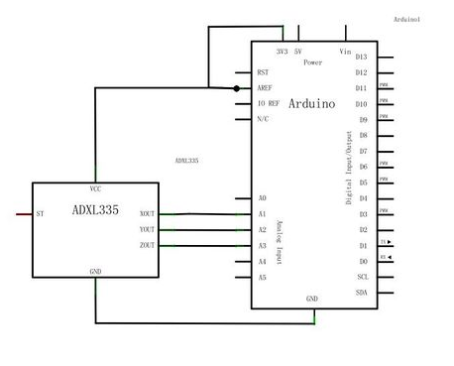

3) **Push Button:**  To interrupt the SMS or voice calls if they are accidentally triggered.

4) **Sim card:** Sim card is used to make the cellular network connection and make voice calls or send text messages.

**Block Diagram:**

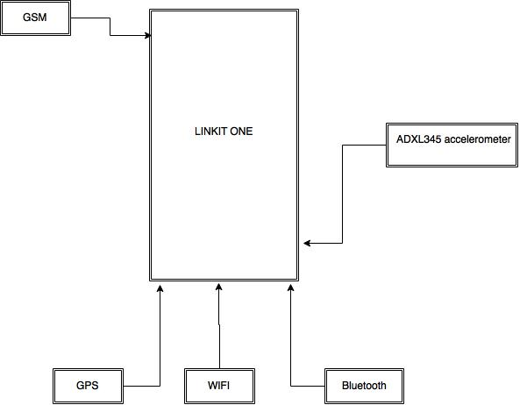

The connections are made as shown in the figure. The Arduino software in installed into a system and can be connected to the setup. The program can be fed to the micro controller. The free fall and GSM libraries are used to detect free fall and activate cellular network respectively.

# Conclusion

We must act on time when a person is injured , if not a valuable life maybe lost, so the innovative Smart Helmet incorporates cost effective and simple technology which  can be used  effectively in reducing the number of fatalities in accidents due to delayed medical care

We arrived upon conclusion that this would reduce many fatalities based upon several factors and features of the helmet we have built. This has been proved by the results of the experiments conducted by us as a part of testing.

# Future Improvements

This smart helmet can be further developed to accommodate alcohol sensors, roadblock sensors to detect roadblocks and alert the users by connecting a small alarm to the controller and  it can be integrated with many existing technologies to provide guidance and on road tracking facilities

It can also be used to detect dangerous terrains, roads and Bridges by installing zone indicators in such areas to alert the Rider in prior.

# References

1. Common Pitfalls in Statistical thinking by Mark C Paulk
2. The Immaturity of CMM by satisfice Inc.
3. https://en.wikipedia.org/wiki/Capability_Maturity_Model